iPad Tips, Tricks, and Problems
Resource Sheet

1. Thumb Mode with the iPad Keyboard
-Take two fingers and place in the middle of the keyboard and swipe out to change to Thumb Mode
-Push the keyboard back together to exit Thumb mode.
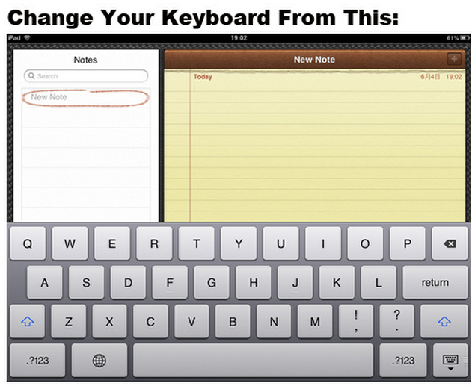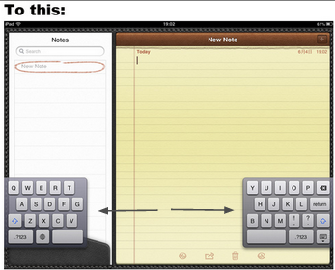

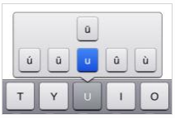
2. Type Special Characters with the Keyboard (try it in Notes)
- Single quotation mark: touch and hold the comma key
- Turn caps lock on/off: double tap the Shift Key to lock, single tap to unlock
- Need an extra space? Push the spacebar with two fingers, it will give you two spaces. Works up to 5 fingers, giving up to 5 spaces.
- Push and hold any key in keyboard.
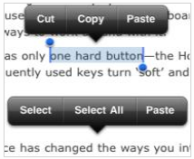
3. Copy and Paste Text (try it in Notes)
-Touch and hold the text you want to copy.
-Drag the handles to adjust the area if needed, then select Cut or Copy.
-Tap the area you want to paste, then select paste.

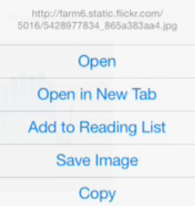
4. Copy and Save an Image (Open up Safari and search for an image you want to copy)
-Select and hold the image until a box of options appears
-Choose save image to save to camera roll or choose copy and paste it into a note or program.

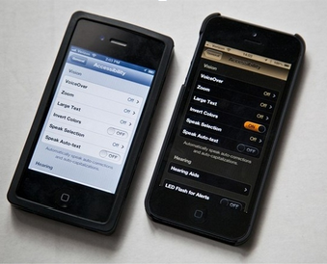
5. Invert Colors (good for low light)
-Go to 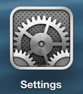settings ---> General ---> Accessibility ---> Turn on/Off
“Invert Colors”

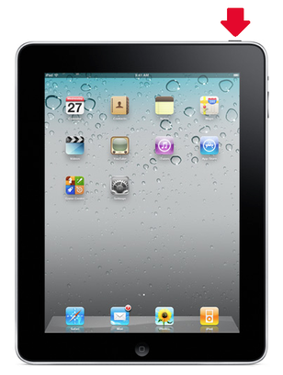
6. A “frozen” or slow iPad: Reboot!
-Hold down the sleep/wake button for several seconds. The iPad will prompt you to slide to power off.
- If that doesn’t work, hold down the sleep/wake button AND the home button for several seconds. This will force the iPad to power down.
-After the screen is blank for a minute, hold the sleep/wake button to turn back on.

7.Access Control Center (fast way to get to music, timer, airplay, camera and brightness)
-Swipe up from bottom of iPad screen (on IOS 7 updated iPads only).
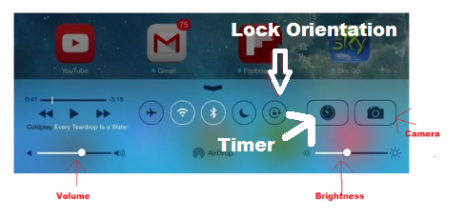
8. Remove/Move apps
-Push and hold any app until it starts to wiggle.
-Any app that has a small x can be deleted by pushing that x.
-You can push and hold a wiggly app and move it to any screen or the dock.

9. Side Switch: Lock Rotation or Mute?
You can choose what function the side switch serves, to lock the rotation of the app, or to mute the volume
-Go to Settings ---> General ---> Find “Use Side Switch to” area and select which option you prefer.

10. Check browsing history in Safari
-When in Safari, in the toolbar, click the bookmark button.
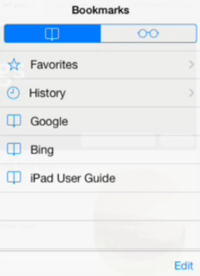
-Select History.

