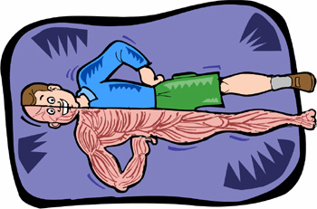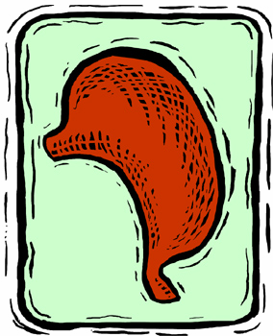

Sides of cube. Turn all graphics 90 degrees counterclockwise.

Top of cube. Use WordArt to create title. Rotate 90 degrees clockwise.

Bottom